Bill Cosby has a great way of distilling things. Looks like he has done it again!

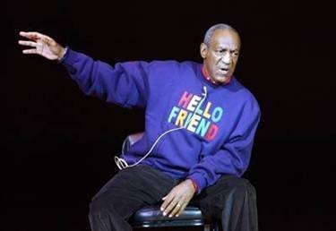

I WISH WE HAD A CANDIDATE WITH THIS PLATFORM!!

I HAVE DECIDED TO BECOME A WRITE-IN CANDIDATE FOR 2012. HERE IS MY PLATFORM:

(1) 'Press 1 for English' is immediately banned. English is the official language; speak it or wait at the border until you can.

(2) We will immediately go into a two year isolationist posture to straighten out the country's attitude. NO imports, no exports. We will use the 'Wal-Mart 's policy, 'If we ain't got it, you don't need it.'

(3) When imports are allowed, there will be a 100% import tax on it.

(4) All retired military personnel will be required to man one of our many observation towers on the southern border (six month tour). They will be under strict orders not to fire on SOUTHBOUND aliens.

(5) Social security will immediately return to its original state. If you didn't put nuttin in, you ain't gettin nuttin out. The president nor any other politician will be able to touch it.

(6) Welfare - Checks will be handed out on Fridays at the end of the 40 hour school week and the successful completion of urinalysis and a passing grade.

(7) Professional Athletes--Steroids. The FIRST time you check positive you’re banned for life.

(8) Crime - We will adopt the Turkish method, the first time you steal, you lose your right hand. There is no more life sentences. If convicted of murder, you will be put to death by the same method you chose for your victim; gun, knife, strangulation, etc.

(9) One export will be allowed, Wheat. The world needs to eat. A bushel of wheat will be the exact price of a barrel of oil.

(10) All foreign aid using American taxpayer money will immediately cease, and the saved money will pay off the national debt and ultimately lower taxes. When disasters occur around the world, we'll ask the American people if they want to donate to a disaster fund, and each citizen can make the decision whether it's a worthy cause.

(11) The Pledge of Allegiance will be said every day at school and every day in Congress.

(12) The National Anthem will be played at all appropriate ceremonies, sporting events, outings, etc.

Sorry if I stepped on anyone's toes

GOD BLESS AMERICA.

Bill Cosby

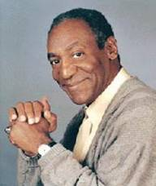

Please forward this to everyone you know, no matter which side of the fence they're on.

